Sales Analysis
Create a New Environment
Create a new environment, in anaconda navigator for FBProphet
Use python version 3.7 (Higher versions it won’t work)

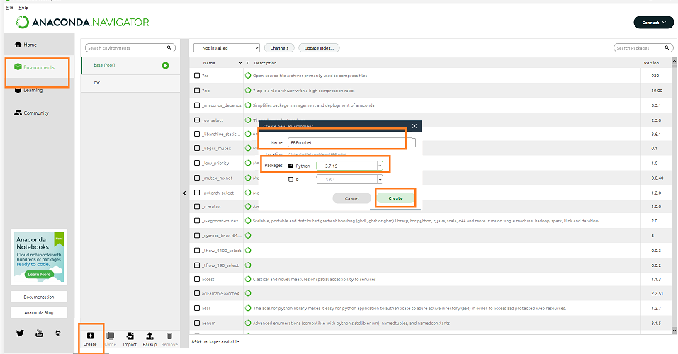

Open Anaconda Prompt
Open Anaconda Prompt with Administrator Privilege


List all environments
conda info --envs
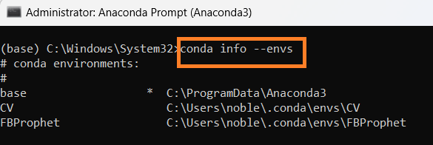

Activate New Environment
activate FBProphet
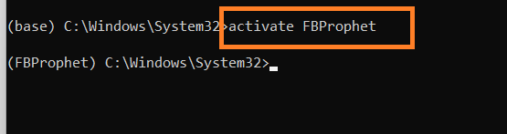

Install the fbprophet
conda install -c conda-forge fbprophet

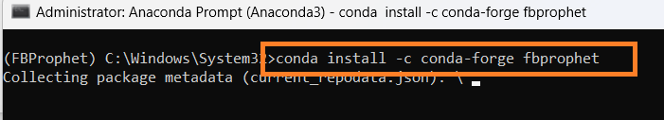

Proceed y
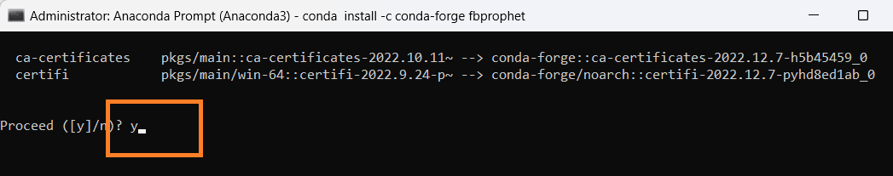
Installation – Complete
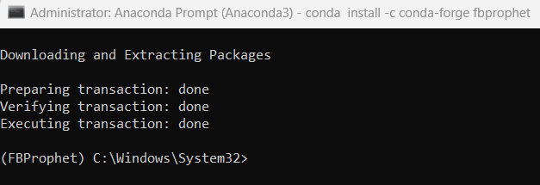

Install the Following
conda install -c conda-forge pystan

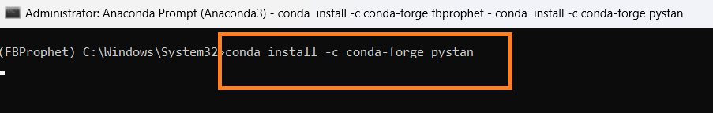

Install the new version of Conda if any error

conda update -n base -c defaults conda
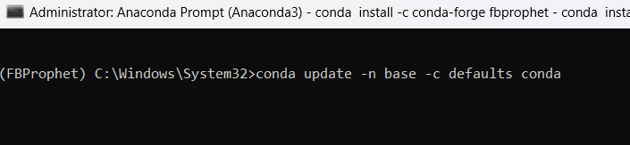

Proceed y

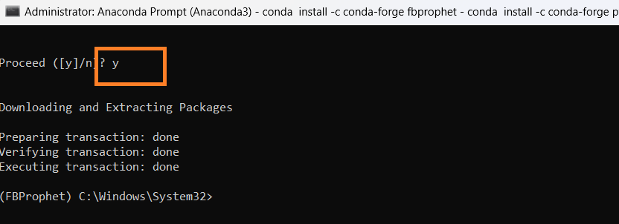

Install the Following -Pystan Again
conda install -c conda-forge pystan



Proceed y /n Enter y
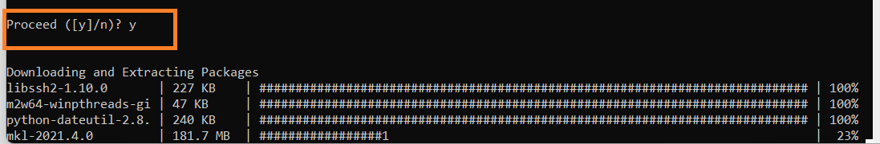

Install the Following -Plotly

pip install plotly

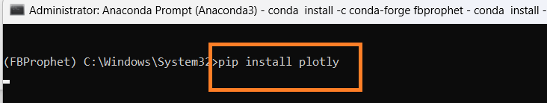

Install the Following -Cufflinks

pip install cufflinks

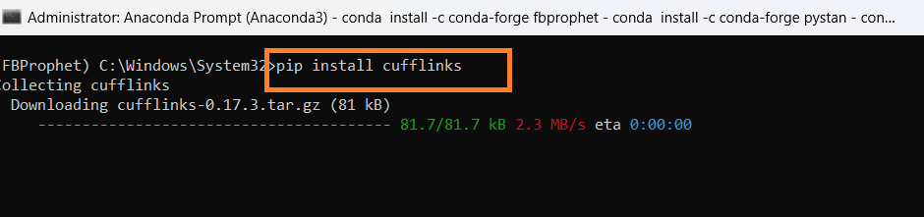

Install Numpy

conda install -c anaconda numpy

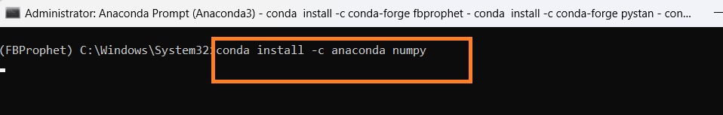

Install Pandas

conda install -c anaconda pandas
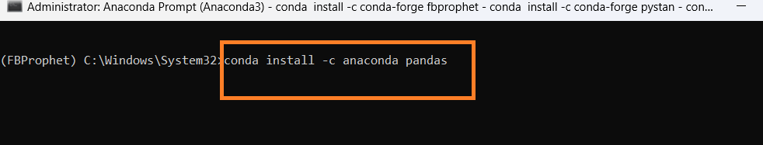

Install Matplotlib

conda install -c conda-forge matplotlib

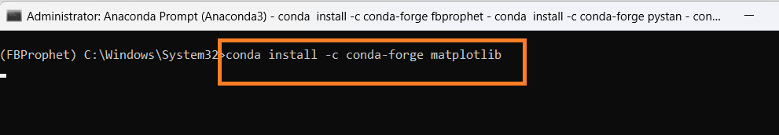

Install Seaborn

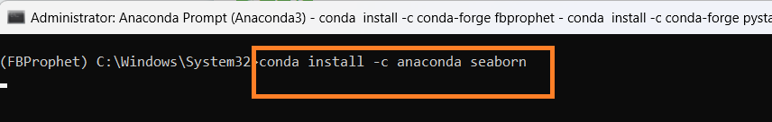

Open Anaconda Navigator
Select the new environment created in Anaconda Navigator FBProphet

Click install to install Jupyter Notebook

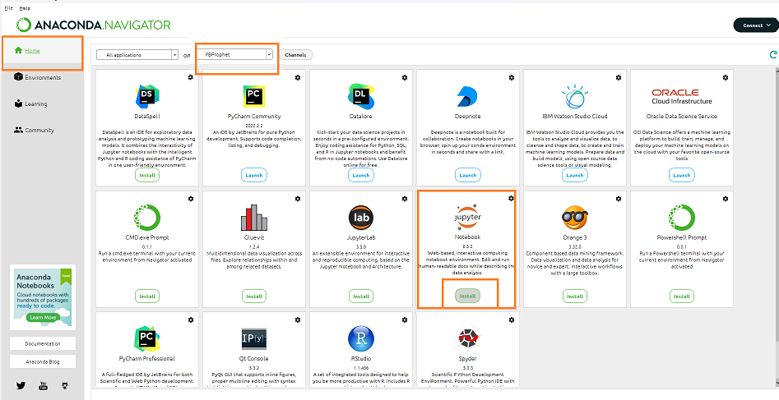

Then Launch Jupyter Notebook in the new environment

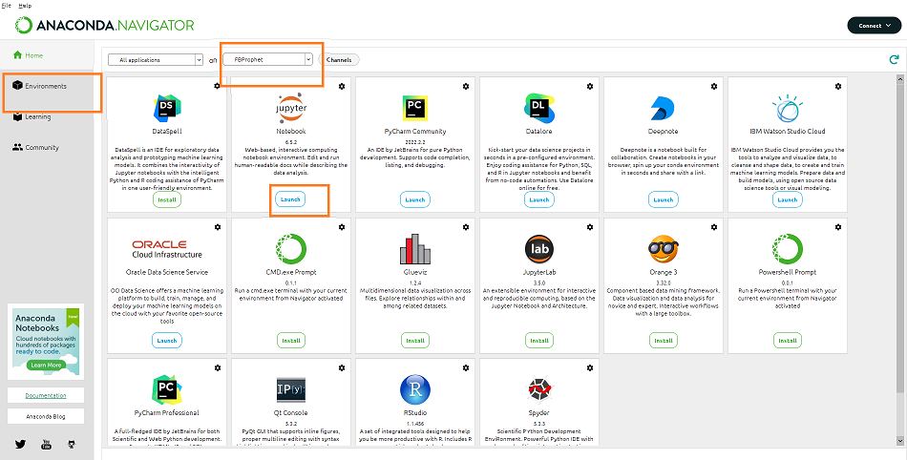

Import Libraries
import pandas as pd
import numpy as np
import seaborn as sns
import matplotlib.pyplot as plt
from matplotlib.dates import MonthLocator, num2date
from matplotlib.ticker import FuncFormatter
import datetime
import os
%matplotlib inline
from matplotlib.pylab import rcParams
rcParams['figure.figsize'] = 20,10

Check Current Directory
print (os.getcwd())

Change the directory

os.chdir ('C:\\Noble\\Training\\Top Mentor\\Training\\Presentation\\Project\\Project -6 Sales Department\\')
print (os.getcwd())

Read Sales Data , display top 5 records
sales_train_df = pd.read_csv('train.csv')
display (sales_train_df.head())
# Almost a million observation
# 1115 unique stores
# Note that sales is the target variable (that's what we are trying to predict)
# Id: transaction ID (combination of Store and date)
# Store: unique store Id
# Sales: sales/day, this is the target variable
# Customers: number of customers on a given day
# Open: Boolean to say whether a store is open or closed (0 = closed, 1 = open)
# Promo: describes if store is running a promo on that day or not
# StateHoliday: indicate which state holiday (a = public holiday, b = Easter holiday, c = Christmas, 0 = None)
# SchoolHoliday: indicates if the (Store, Date) was affected by the closure of public schools

Display the shape (number of rows and columns)
display (sales_train_df.shape)

Display the bottom 5 records
display (sales_train_df.tail())
Data Frame Details
display (sales_train_df.info())
# 9 columns in total
# 8 features, each containing 1017209 data points
# 1 target variable (sales)
Describe Sales Data Frame
display (sales_train_df.describe())
# Average sales amount per day = 5773 Euros, minimum sales per day = 0, maximum sales per day = 41551
# Average number of customers = 633 per day, minimum number of customers = 0, maximum number of customers = 7388

Import Store Data
store_info_df = pd.read_csv('store.csv')
display (store_info_df.head())

# StoreType: categorical variable to indicate type of store (a, b, c, d)
# Assortment: describes an assortment level: a = basic, b = extra, c = extended
# CompetitionDistance (meters): distance to closest competitor store
# CompetitionOpenSince [Month/Year]: provides an estimate of the date when competition was open
# Promo2: Promo2 is a continuing and consecutive promotion for some stores - Check is the store participate additional promotions (0 = store is not participating, 1 = store is participating)
# Promo2Since [Year/Week]: date when the store started participating in Promo2
# PromoInterval: Duration of promo in months.Describes the consecutive intervals Promo2 is started, naming the months the promotion is started anew. E.g. "Feb,May,Aug,Nov" means each round starts in February, May, August, November of any given year for that store

Display the shape (number of rows and columns)
display (store_info_df.shape)

Store Data Details - Info

# This dataframe only includes information about the unique 1115 stores that are part of this study
display (store_info_df.info())

Store Data Details -Describe
display (store_info_df.describe())
# on average, the competition distance is 5404 meters away (5.4 kms)

EXPLORE DATASET

EXPLORE SALES DATA

Check number of Null records
print (sales_train_df.isna().sum())

Plot Missing Data – Heat Map to check missing data, in this case no graph created , no missing data
# Check if any missing data with seaborn heat hap
# sns.heatmap(sales_train_df.isnull(), yticklabels = False, cbar ( Colour bar) = False, cmap="Blues")
sns.heatmap(sales_train_df.isnull(), yticklabels = False, cbar = False, cmap="Blues")
plt.show()

Create Histogram of sales data. Histogram created for numeric columns
sales_train_df.hist(bins = 30, figsize = (20,20), color = 'r')
plt.show()

# Few observations from Histogram
#Average 600 customers per day, maximum is 4500
# Data is equally distributed across various Days of the week (~150000 observations x 7 day = ~1.1 million observation)
# Stores are open ~80% of the time
# Data is equally distributed among all stores (no bias)
# Promo #1 was running ~40% of the time
# Average sales around 5000-6000
# School holidays are around ~18% of the time

Maximum number of customers in a store in a day.
display (sales_train_df['Customers'].max())

Number of stores open or closed
closed_train_df = sales_train_df[sales_train_df['Open'] == 0]
open_train_df = sales_train_df[sales_train_df['Open'] == 1]

Count the number of stores that are open and closed
print("Total =", len(sales_train_df))
print("Number of closed stores =", len(closed_train_df))
print("Number of open stores =", len(open_train_df))

Remove closed store sales records
# Only keep open stores and remove closed stores, since there no sales for closed stores, sales are 0 for closed store

sales_train_df = sales_train_df[sales_train_df['Open'] == 1]

Display the data after removing closed store data
display(sales_train_df)

Drop the open column since it has no meaning now
sales_train_df.drop(['Open'], axis=1, inplace=True)
display(sales_train_df)

Describe the data
display (sales_train_df.describe())
# Average sales = 6955 average number of customers = 762 (went up)

EXPLORE STORES INFORMATION DATA
Check missing data
display (store_info_df.isna().sum())

Heat Map to check missing Data
# Check missing data in the store information data frame
sns.heatmap(store_info_df.isnull(), yticklabels = False, cbar = False, cmap="Blues")
plt.show()
Display Records with missing column - Column - CompetitionDistance

# Display records with missing values in the 'CompetitionDistance' column
# Only 3 rows are missing
display (store_info_df[store_info_df['CompetitionDistance'].isnull()])

Display Records with missing column - Column - CompetitionOpenSinceMonth
# Display records with missing values in the 'CompetitionOpenSinceMonth' column
# Many rows are missing = 354 (almost one third of the 1115 stores)

display (store_info_df[store_info_df['CompetitionOpenSinceMonth'].isnull()])

Display all records with Promo2 = 0
display (store_info_df[ store_info_df['Promo2'] == 0])

# It seems like if 'promo2' is zero, 'promo2SinceWeek', 'Promo2SinceYear', and 'PromoInterval' information is set to zero

Display Records with missing column - Column - CompetitionOpenSincYear

# Display records with missing values in the column'CompetitionOpenSinceYear No of records 354'
display (store_info_df[store_info_df['CompetitionOpenSinceYear'].isnull()])

Display Records with missing values in column -CompetitionOpenSincMonth

# Display records with missing values in the column'CompetitionOpenSinceMonth No of records 354'
display (store_info_df[store_info_df['CompetitionOpenSinceMonth'].isnull()])

Update Null Columns with 0

# There are 354 rows where 'CompetitionOpenSinceYear' and 'CompetitionOpenSinceMonth' is missing
# Update the following columns to zeros , if null
str_cols = ['Promo2SinceWeek', 'Promo2SinceYear', 'PromoInterval', 'CompetitionOpenSinceYear', 'CompetitionOpenSinceMonth']

for str in str_cols:
store_info_df [str].fillna(0, inplace = True)

Check for NULL values
display (store_info_df.isna().sum())

Create heat map to check for NULL values
sns.heatmap(store_info_df.isnull(), yticklabels = False, cbar = False, cmap="Blues")
plt.show()

Missing Values column - CompetitionDistance'

# There are 3 rows with 'competitionDistance' values missing, let's fill them up with with average values of the 'CompetitionDistance' column
store_info_df['CompetitionDistance'].fillna(store_info_df['CompetitionDistance'].mean(), inplace = True)

Check for NULL values
display (store_info_df.isna().sum())

Create heat map to check for NULL values
sns.heatmap(store_info_df.isnull(), yticklabels = False, cbar = False, cmap="Blues")
plt.show()

Create histogram to View Data
store_info_df.hist(bins = 30, figsize = (20,20), color = 'r')
plt.show()
# half of stores are involved in promo 2
# half of the stores have their competition at a distance of 0-3000m (3 kms away)

EXPLORE MERGED DATASET
Merge Both Data Frames
# Let's merge both data frames together based on 'store'
sales_train_all_df = pd.merge(sales_train_df, store_info_df, how = 'inner', on = 'Store')

Display Merged Data Frames
# Create .csv file with merged data set
sales_train_all_df.to_csv('merged_test.csv', index=False)

Create .csv file with merged data set
sales_train_all_df.to_csv('merged_test.csv', index=False)

Create corelation with Sales Columns

correlations = sales_train_all_df.corr()['Sales'].sort_values()
print (correlations)

# Customers and promo are positively correlated with the sales
# Promo2 does not seem to be effective at all

Create heat Map to check co relation
correlations = sales_train_all_df.corr()
f, ax = plt.subplots(figsize = (20, 20))
sns.heatmap(correlations, annot = True)
plt.show()
# Customers/Prmo2 and sales are strongly correlated

Extract Year from Date Column
# Separate the year from the date column and put it into a separate column
sales_train_all_df['Year'] = pd.DatetimeIndex(sales_train_all_df['Date']).year
display(sales_train_all_df)

Extract Month and Day Column
# Same way extract month and day column, add as separate columns
sales_train_all_df['Month'] = pd.DatetimeIndex(sales_train_all_df['Date']).month
sales_train_all_df['Day'] = pd.DatetimeIndex(sales_train_all_df['Date']).day
display(sales_train_all_df)

Average Sales by Month

# Let's take a look at the average sales per month
# 'groupby' works great by grouping all the data that share the same month column, then obtain the mean of the sales column
# It looks like sales peak around christmas timeframe
axis = sales_train_all_df.groupby('Month')[['Sales']].mean().plot(figsize = (20,10), marker = 'o', color = 'r')
axis.set_title('Average Sales Per Month')
plt.show()

Average Customer by Month
# It looks like number of customers peak around christmas timeframe

plt.figure()
axis = sales_train_all_df.groupby('Month')[['Customers']].mean().plot(figsize = (20,10), marker = '^', color = 'b')
axis.set_title('Average Customers Per Month')
plt.show()

Display the sales and customers per day of the month instead
# Minimum number of customers are generally around the 24th of the month
# Most customers and sales are around 30th and 1st of the month
ax = sales_train_all_df.groupby('Day')[['Sales']].mean().plot(figsize = (20,5), marker = 'o', color = 'r')
axis.set_title('Average Sales Per Day')

plt.figure()
ax = sales_train_all_df.groupby('Day')[['Customers']].mean().plot(figsize = (20,5), marker = '^', color = 'b')
axis.set_title('Average Sales Per Day')
plt.show()

Display the sales and customers based on day of the week
# Display the sales and customers for the day of the week (note that 7 = Sunday)

axis = sales_train_all_df.groupby('DayOfWeek')[['Sales']].mean().plot(figsize = (20,10), marker = 'o', color = 'r')
axis.set_title('Average Sales Per Day of the Week')

plt.figure()
axis = sales_train_all_df.groupby('DayOfWeek')[['Customers']].mean().plot(figsize = (20,10), marker = '^', color = 'b')
axis.set_title('Average Customers Per Day of the Week')
plt.show()

Average Sales by Store Type by Day (Store Type : a,b,c,d)
fig, ax = plt.subplots(figsize=(20,10))
sales_train_all_df.groupby(['Date','StoreType']).mean()['Sales'].unstack().plot(ax=ax)
plt.show()

# Store b has average highest sales and store a has average lowest sales

Average Sales by Store Type by Day without unstack
#Plot the above graph without unstack
fig, ax = plt.subplots(figsize=(20,10))
sales_train_all_df.groupby(['Date','StoreType']).mean()['Sales'].plot(ax=ax)
plt.show()

Graph – Impact of Promo on Sales and Customers – Bar Graph

plt.figure(figsize=[20,15])

plt.subplot(211)
sns.barplot(x = 'Promo', y = 'Sales', data = sales_train_all_df)

plt.subplot(212)
sns.barplot(x = 'Promo', y = 'Customers', data = sales_train_all_df)

Graph – Impact of Promo on Sales and Customers – violinplot
plt.figure(figsize=[20,15])

plt.subplot(211)
sns.barplot(x = 'Promo', y = 'Sales', data = sales_train_all_df)

plt.subplot(212)
sns.barplot(x = 'Promo', y = 'Customers', data = sales_train_all_df)
plt.show()

Graph – Impact of Promo on Sales and Customers – Boxplot

plt.figure(figsize=[20,15])

plt.subplot(211)
sns.violinplot(x = 'Promo', y = 'Sales', data = sales_train_all_df)

plt.subplot(212)
sns.violinplot(x = 'Promo', y = 'Customers', data = sales_train_all_df)
plt.show()

TRAIN THE MODEL
Import Library
from fbprophet import Prophet

Create the Function for Forecasting, prediction based on the specified store ie store id

def sales_prediction(Store_ID, sales_df, periods):
# Function that takes in the data frame, storeID, and number of future period forecast
# The function then generates date/sales columns in Prophet format ie Rename Date column to ds and Sales to y
# The function then makes time series predictions

sales_df = sales_df[ sales_df['Store'] == Store_ID ]
# Create the data frame by selecting the data based on selected store id
sales_df = sales_df[['Date', 'Sales']].rename(columns = {'Date': 'ds', 'Sales':'y'})
# Rename the column

sales_df = sales_df.sort_values('ds')

model = Prophet() # Create the model
model.fit(sales_df)
future = model.make_future_dataframe(periods=periods)
forecast = model.predict(future)
figure = model.plot(forecast, xlabel='Date', ylabel='Sales')
figure2 = model.plot_components(forecast)

Call the function to predict for next 60 periods
sales_prediction(10, sales_train_all_df, 60)

Predict the sales for next 60 days for store 6 on State Holiday and School Holiday
- State Holiday: indicates a state holiday. Normally all stores, with few exceptions, are closed on state holidays. Note that all schools are closed on public holidays and weekends. a = public holiday, b = Easter holiday, c = Christmas, 0 = None
- School Holiday: indicates if the (Store, Date) was affected by the closure of public schools

Updated Function to predict on Holidays- Included one more input holidays

def sales_prediction(Store_ID, sales_df, holidays, periods):
# Function that takes in the storeID and returns two date/sales columns in Prophet format
# Format data to fit prophet

sales_df = sales_df[ sales_df['Store'] == Store_ID ]
sales_df = sales_df[['Date', 'Sales']].rename(columns = {'Date': 'ds', 'Sales':'y'})
sales_df = sales_df.sort_values('ds')

model = Prophet(holidays = holidays)
model.fit(sales_df)
future = model.make_future_dataframe(periods = periods)
forecast = model.predict(future)
figure = model.plot(forecast, xlabel='Date', ylabel='Sales')
figure2 = model.plot_components(forecast)

Get all the dates related to school holidays
school_holidays = sales_train_all_df[sales_train_all_df['SchoolHoliday'] == 1].loc[:, 'Date'].values
display (school_holidays.shape)

Print school holidays
display(school_holidays)

Get all the dates related to state holidays
state_holidays = sales_train_all_df [ (sales_train_all_df['StateHoliday'] == 'a') | (sales_train_all_df['StateHoliday'] == 'b') | (sales_train_all_df['StateHoliday'] == 'c') ].loc[:, 'Date'].values
display (state_holidays.shape)

Print State Holidays
state_holidays = pd.DataFrame({'ds': pd.to_datetime(state_holidays),
'holiday': 'state_holiday'})
display(state_holidays )

Print School Holidays

school_holidays = pd.DataFrame({'ds': pd.to_datetime(school_holidays),
'holiday': 'school_holiday'})
display (school_holidays)

Display School and State Holidays

# Concat state and scholl holidays
school_state_holidays = pd.concat((state_holidays, school_holidays))
display (school_state_holidays)

Sales Prediction for 60 Day for School and state holidays
sales_prediction(6, sales_train_all_df, school_state_holidays, 60)

